How to take SafeSport Training for returning volunteers:
You will need to log into your account at www.registerusasoftball.com. Remember, this email is not the same as what you used to register your daughter for softball through Sports Engine.
Once in, you will be on your “HomePlate”. About mid-page, there will be several tabs – “Background Check”, “ACE Education”, “SafeSport”. Click on SafeSport.

Towards the middle of the page on the SafeSport tab, there will be 2 blue rectangles under the words “Ready to get started?” Click on the “SafeSport Returning User Login” button.
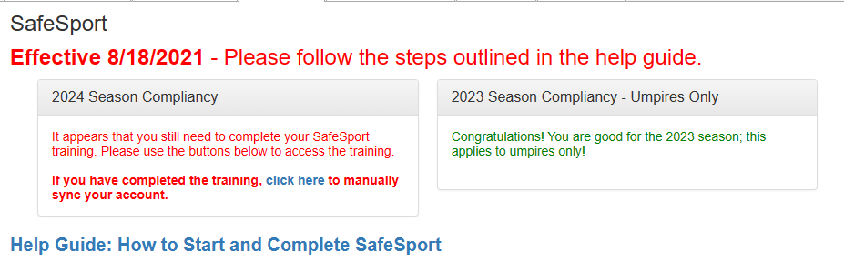
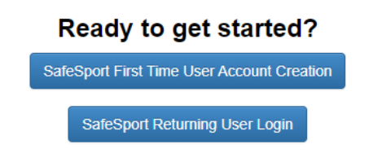
You will be taken to SafeSport. When logging in, you will use your username (most likely your email address) and then click on the “forgot password” button. You must change your password.
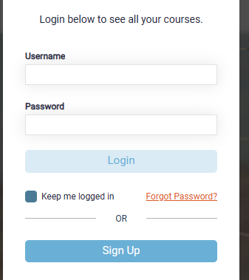
You will be emailed a link to reset your password. Change your password and then login. You will then be on your dashboard which should look like this:
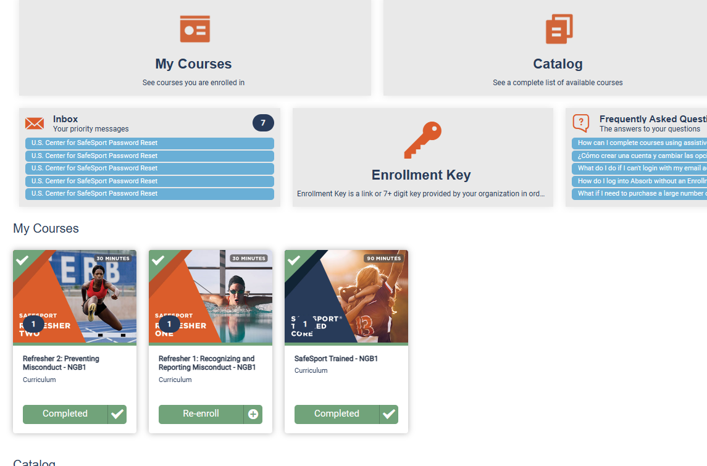
The course you need to take should be at the far left and say start in the green box. If there is nothing there, you will need to scroll further down to find your class. If this is your 2nd year, you will take refresher 1.
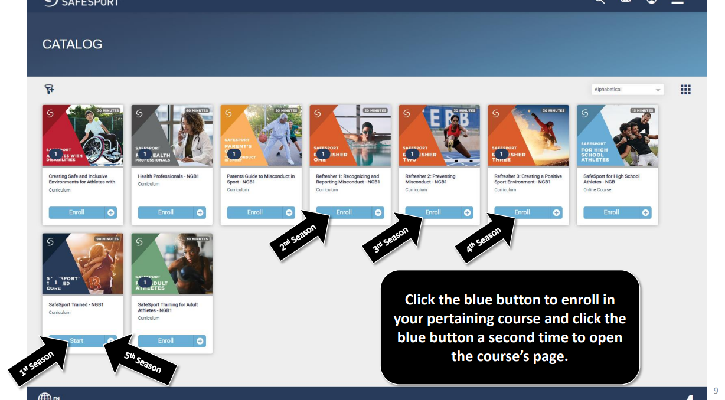
Click on that course and enjoy! When complete, take a screenshot of your completion certificate and send to volunteers.tcgfsa@gmail.com
DO NOT SKIP THIS LAST STEP!!
Log back into your account at www.registerusasoftball.com and go back to the SafeSport tab.
If it looks like this…
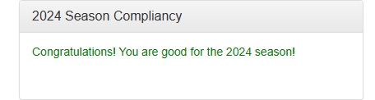
You have successfully completed SafeSport training.
If you see this…
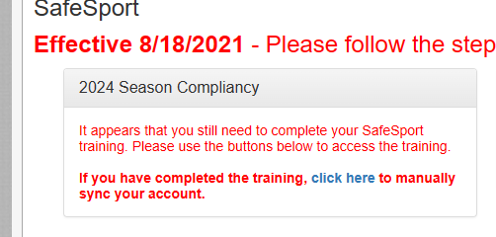

Click on the “click here” link. You will be prompted to enter your SafeSport username and SafeSport password. Then click the “Sync” button.

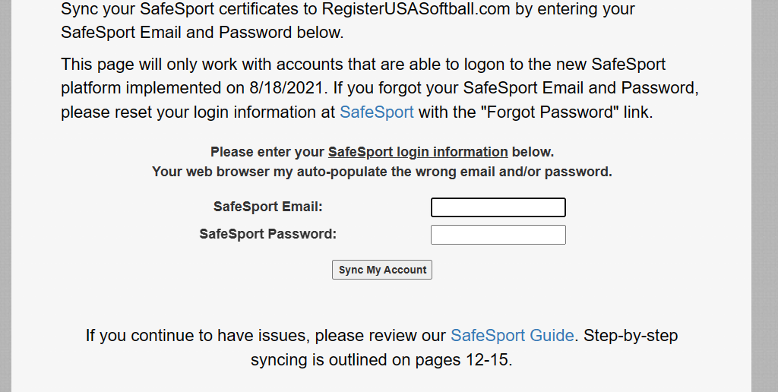

That should complete your SafeSport training.
If you are unable to sync your account, make sure your Safe Sport Username is the email from usaregistersoftball.com. That should fix the problem.

