How to take SafeSport Training for first time users:

You will need to create an account in [www.registerusasoftball.com](http://www.registerusasoftball.com)**. DO NOT** use the email address that you used to register your daughter for league.

You will need to provide your personal information as well as some league information.

**Association** should be WA-Washington, **NOT** WA-Seattle

**Group** should be JO IN Registration (Youth)

**League** should be District 03/Benton, Columbia, etc.

**Organization** can either be TCGFSA or USA Softball

When you have filled in all the required fields and submitted, you will be asked to verify some of your information.

When that is done, you will be taken to your “HomePlate”. About mid-page, there will be several tabs – “Background Check”, “ACE Education”, “SafeSport”. Click on SafeSport.



Towards the middle of the page on the SafeSport tab, there will be 2 blue rectangles under the words “Ready to get started?” Click on the First Time User button.

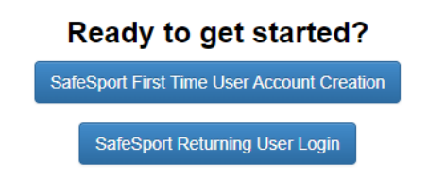

You will need to create an account in SafeSport. Keep your username (**Username must be the email you used in** [**www.registerusasoftball.com**](http://www.registerusasoftball.com)) and password close, you will need them again. Fill out all required fields. For name of Sport or Community Organization, put TCGFSA.

Once your account is created, scroll down about mid page and there should be several courses available. As a first time user, you will need to take **SafeSport Trained Core – NGB1**

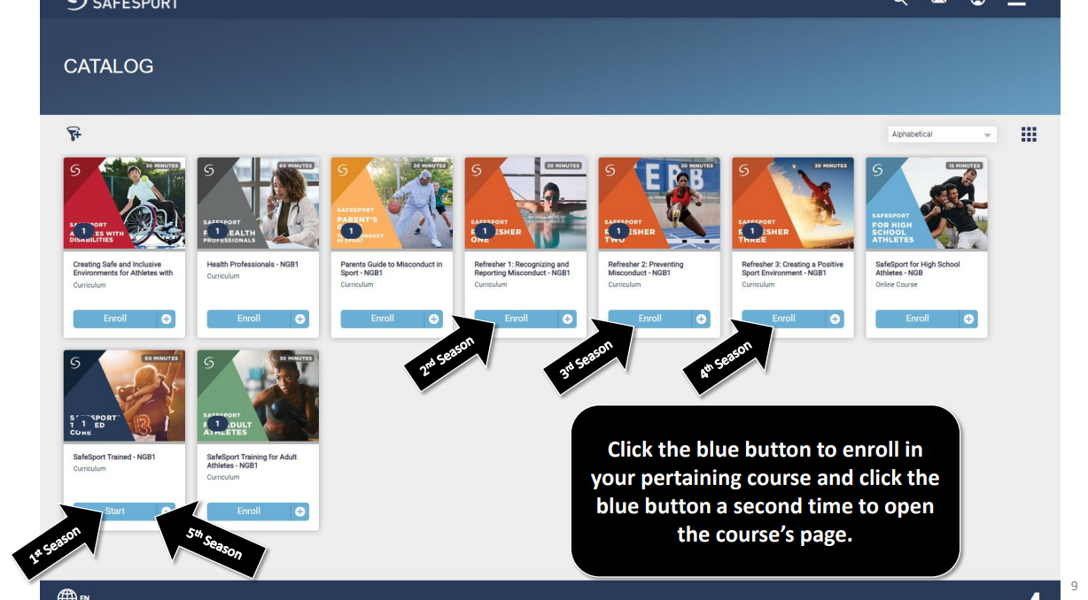

Click on that course and enjoy! When complete, take a screenshot of your completion certificate and send to [volunteers.tcgfsa@gmail.com](mailto:volunteers.tcgfsa@gmail.com)

**DO NOT SKIP THIS LAST STEP!!**

Log back into your account at [www.registerusasoftball.com](http://www.registerusasoftball.com) and go back to the SafeSport tab.

If it looks like this…

You have successfully completed SafeSport training.

**If you see this…**

Click on the “click here” link. You will be prompted to enter your SafeSport username and SafeSport password. Then click the “Sync” button. Pay no attention to the 2024, yours will say 2025.

That should complete your SafeSport training.

REMEMBER, YOUR SAFESPORT EMAIL/USERNAME and REGISTERUSASOFTBALL EMAIL MUST BE THE SAME.